Name: Noah Nguyen

R Lab 8: Introduction to Linear Regression

Please answer all the Exercises and the questions from the “On Your Own” section. If you use any graphs or charts to justify your answer, please include them.

Exercise 1: What type of plot would you use to display the relationship between runs and one of the other numerical variables? Plot this relationship using the variable at_bats as the predictor. Does the relationship look linear? If you knew a team’s at_bats, would you be comfortable using a linear model to predict the number of runs? (Include plot.)
plot(mlb11$at_bats,mlb11$runs, xlab = "At Bats", ylab = "Runs", col = 'red')
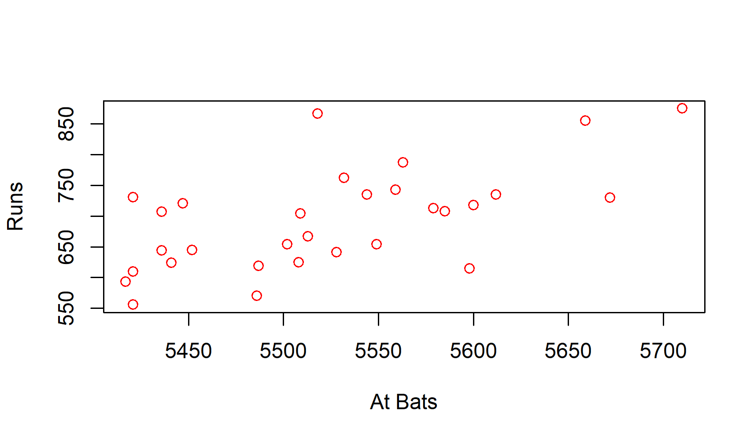
Without knowing a team’s at_bats, it’s hard to use a linear model to predict the number of runs as we don’t know what the distribution looks like. Knowing a team’s at_bats and the plot above, the linear model would be pretty appropriate to use as the relationship looks linear.
The relationship looks linear. We can quantify the strength of the relationship with the correlation coefficient.
Exercise 2: Looking at your plot from the previous exercise, describe the relationship between these two variables. Make sure to discuss the form, direction, and strength of the relationship as well as any unusual observations.

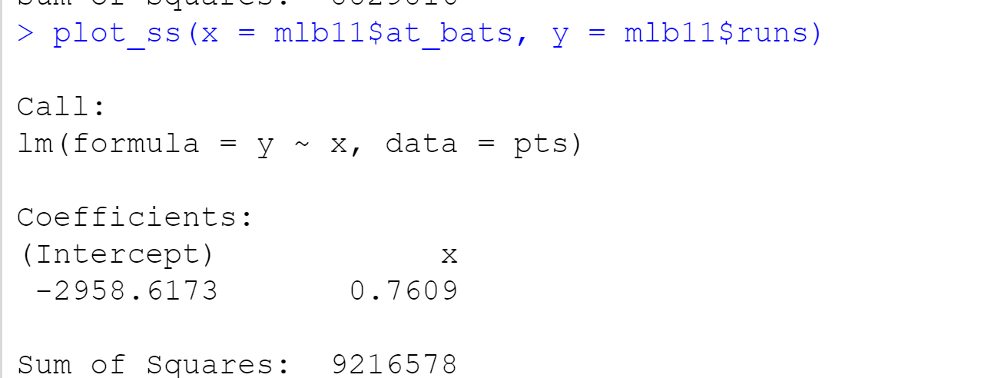
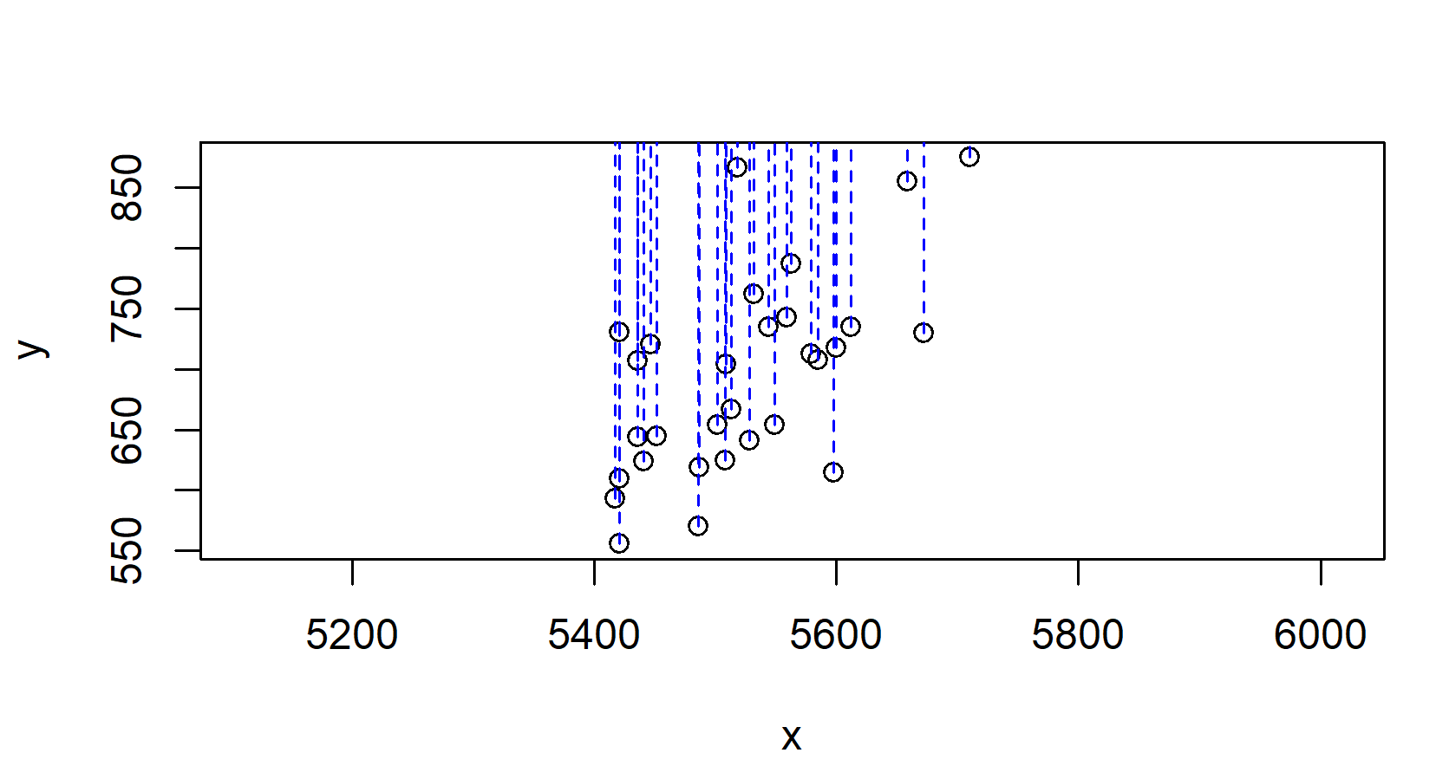
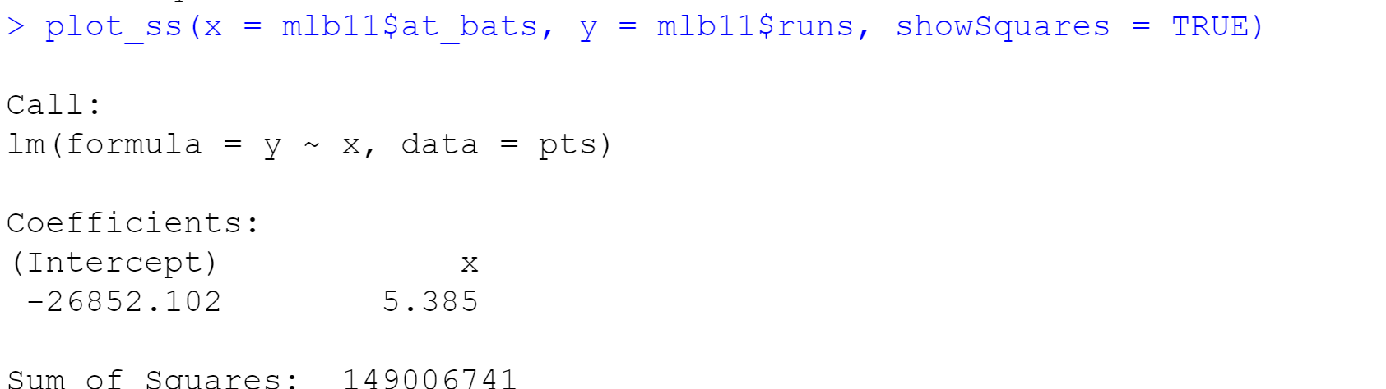

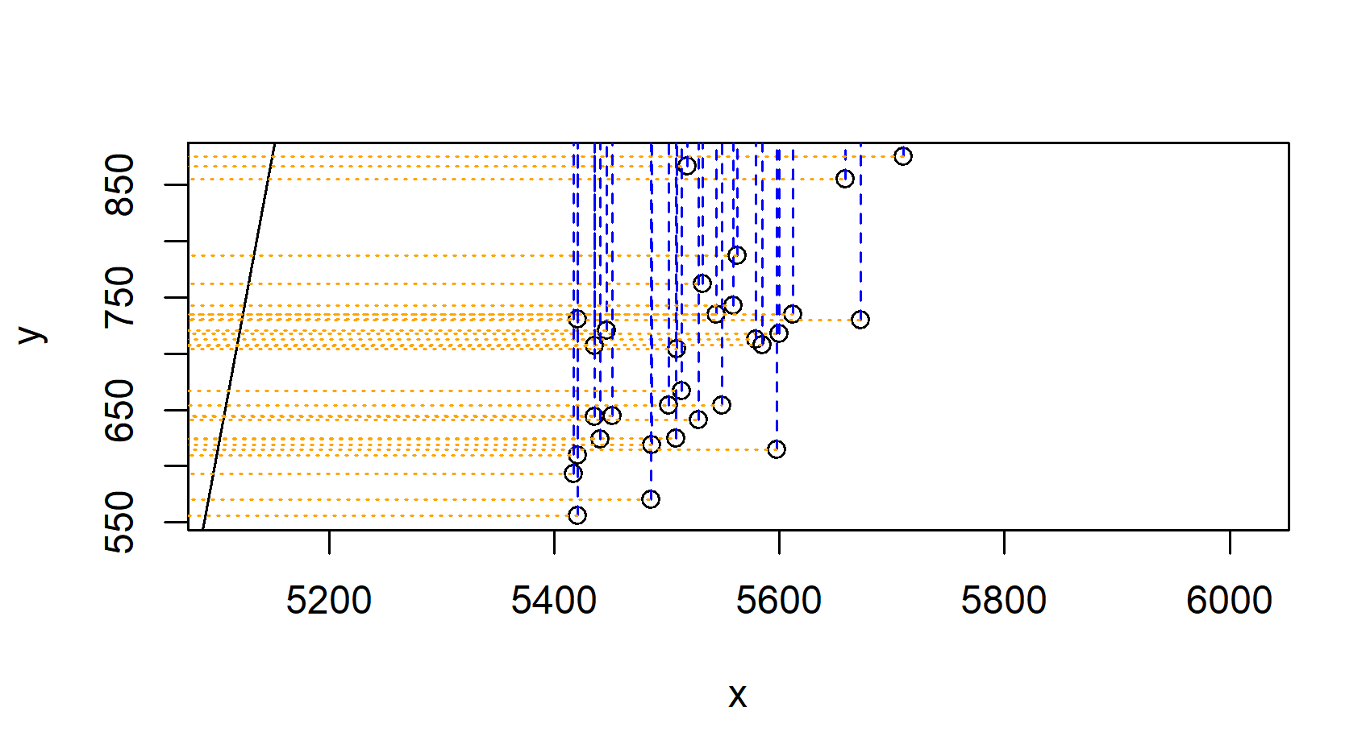
The relationship looks linear and pretty strong. The direction of the line is positive. We can clearly see the residuals on the plot.

Exercise 3: Using plot_ss, choose a line that does a good job of minimizing the sum of squares. Run the function several times. What was the smallest sum of squares that you got? (Include plot of your best line.)
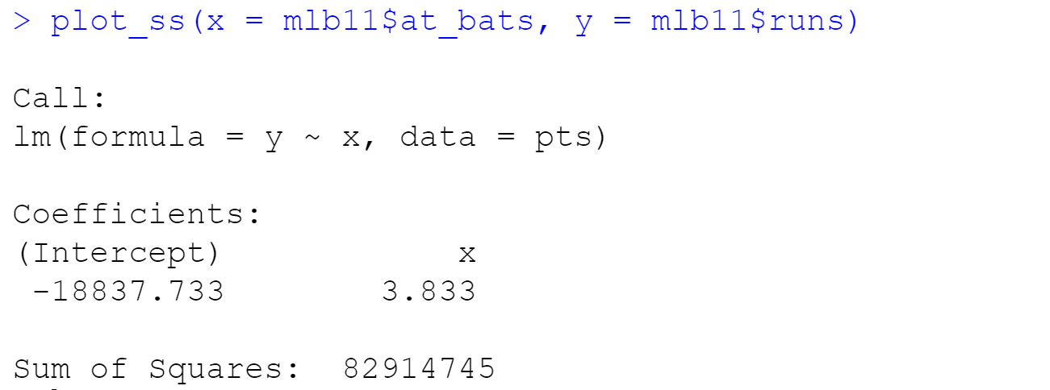
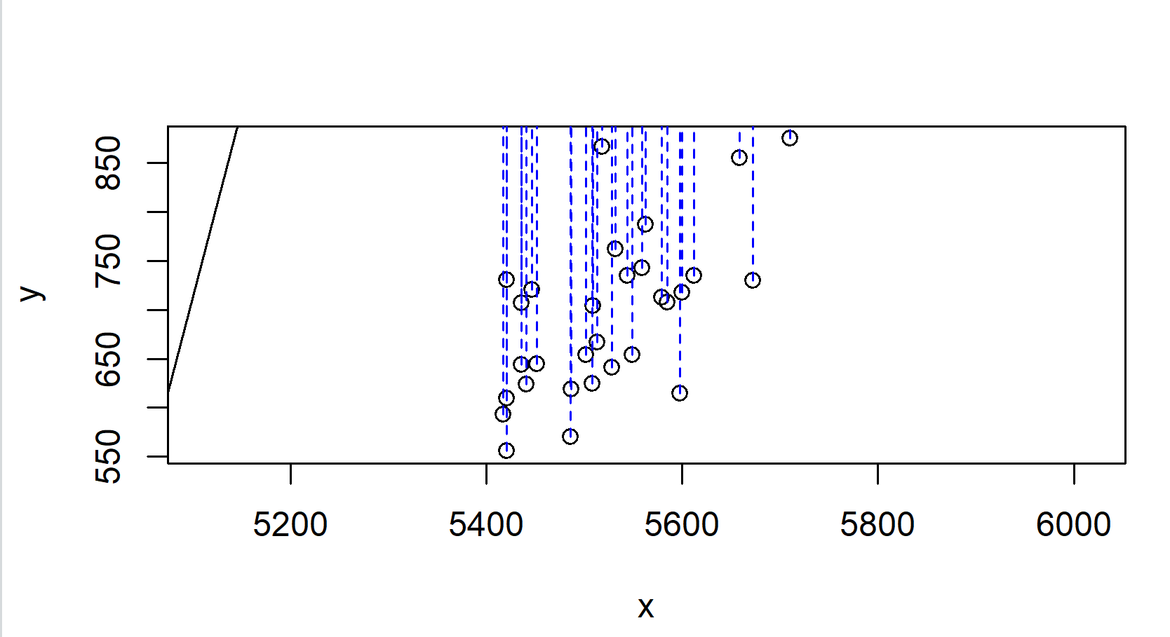
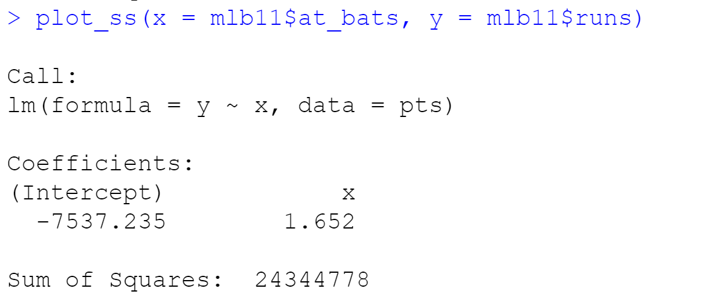
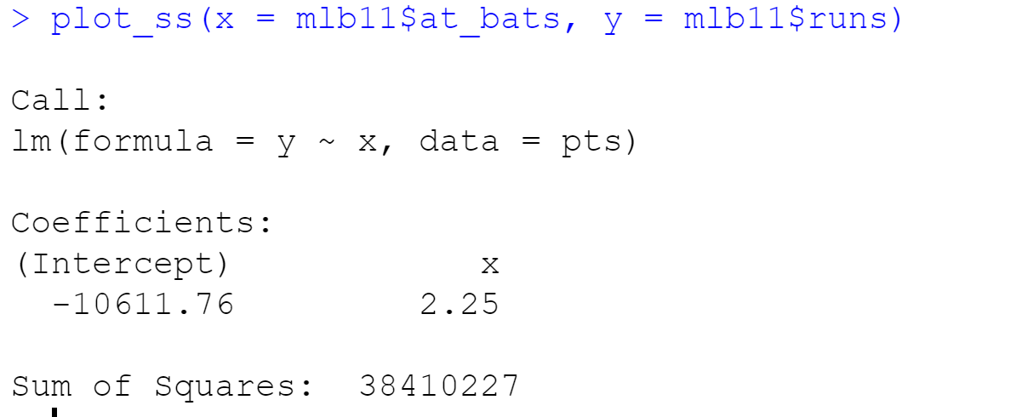
I ran the function 3 times and the smallest sum of squares I got is 24344778.

Exercise 4: Fit a new model that uses homeruns to predict runs. Using the estimates from the R output, write the equation of the regression line. What does the slope tell us in the context of the relationship between success of a team and its home runs?

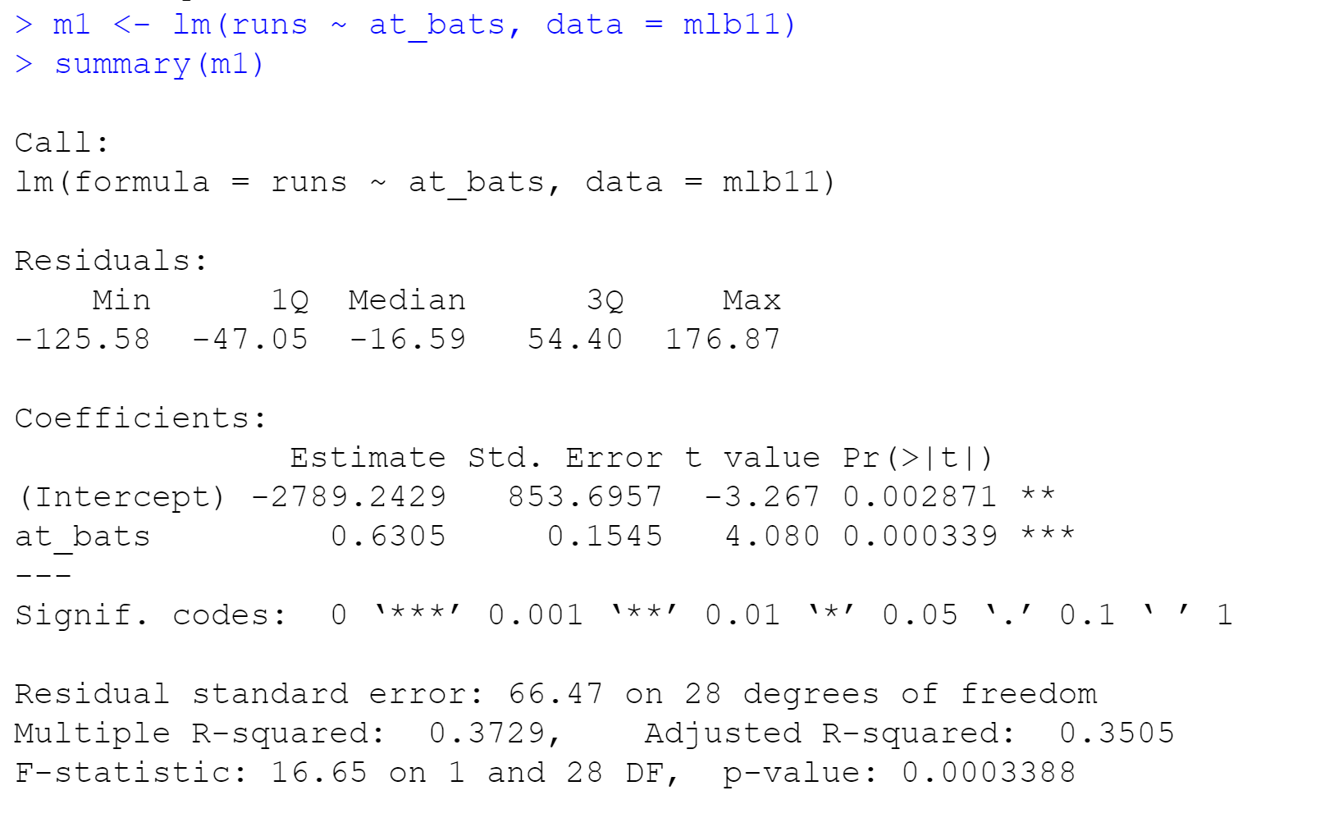
A new model that uses homeruns to predict runs:
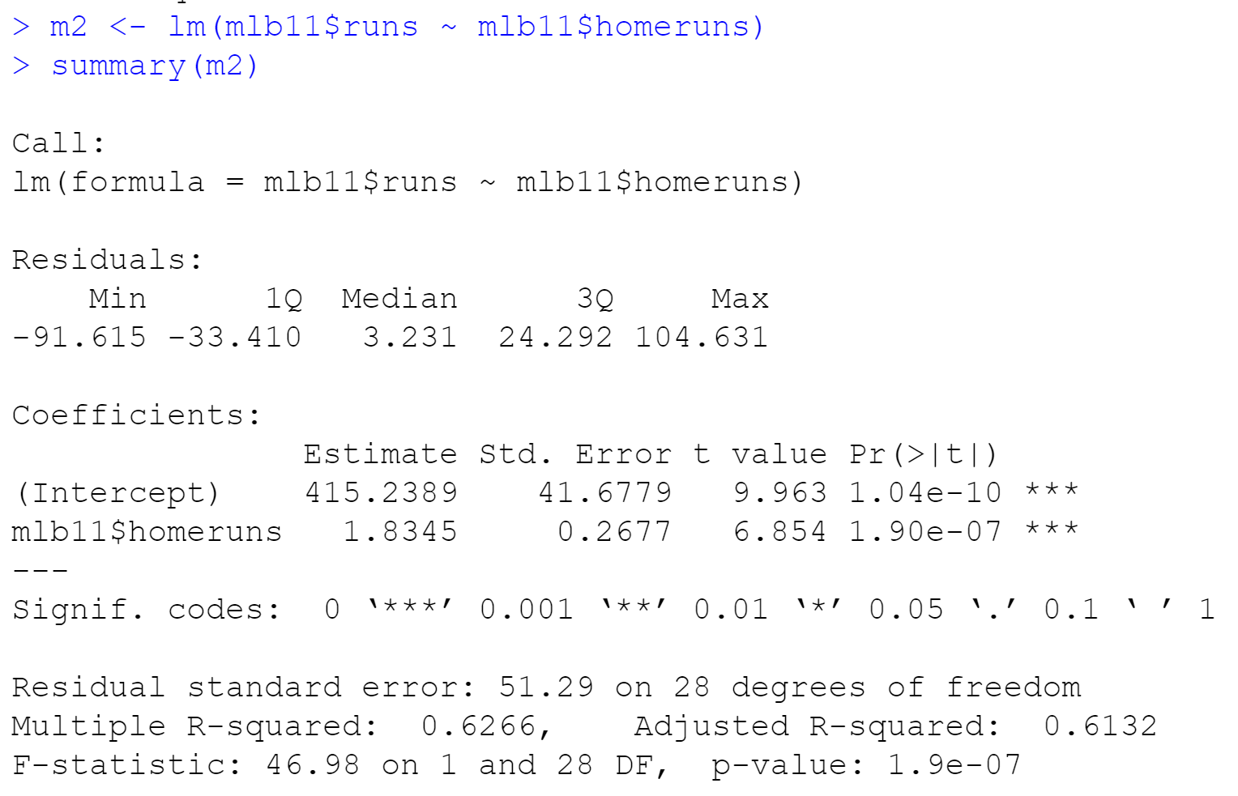
From the model above, we found the function: runs = 415.2389 + 1.8345 * homeruns
The slope is positive, which means that there’s an increasing trend. Those who makes more homeruns will make more runs.
Exercise 5: If a team manager saw the least squares regression line and not the actual data, how many runs would he or she predict for a team with 5,579 at-bats? Is this an overestimate or an underestimate, and by how much? In other words, what is the residual for this prediction?
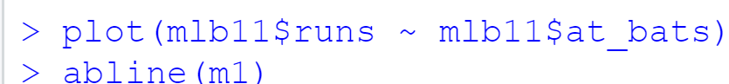
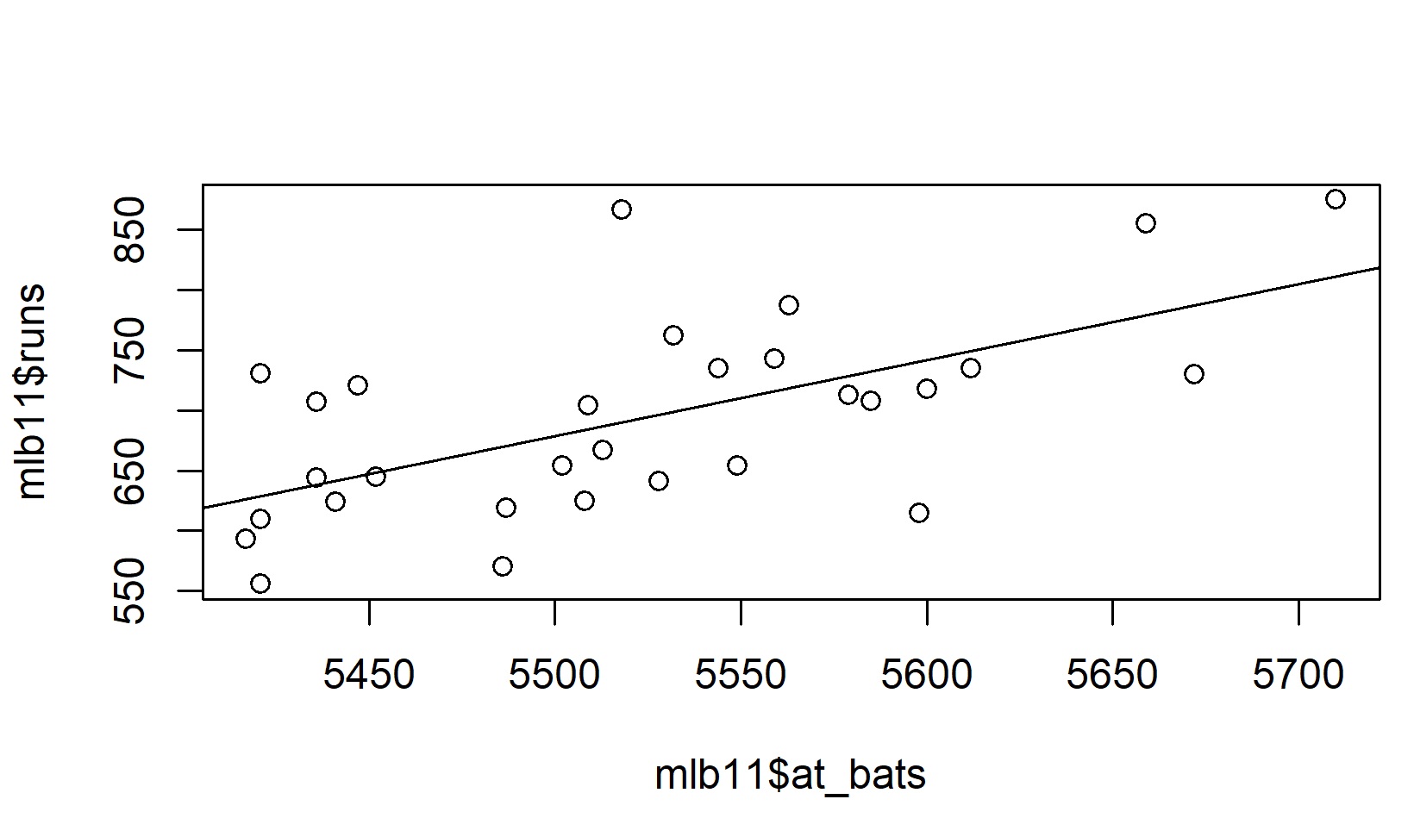
From what I have above:
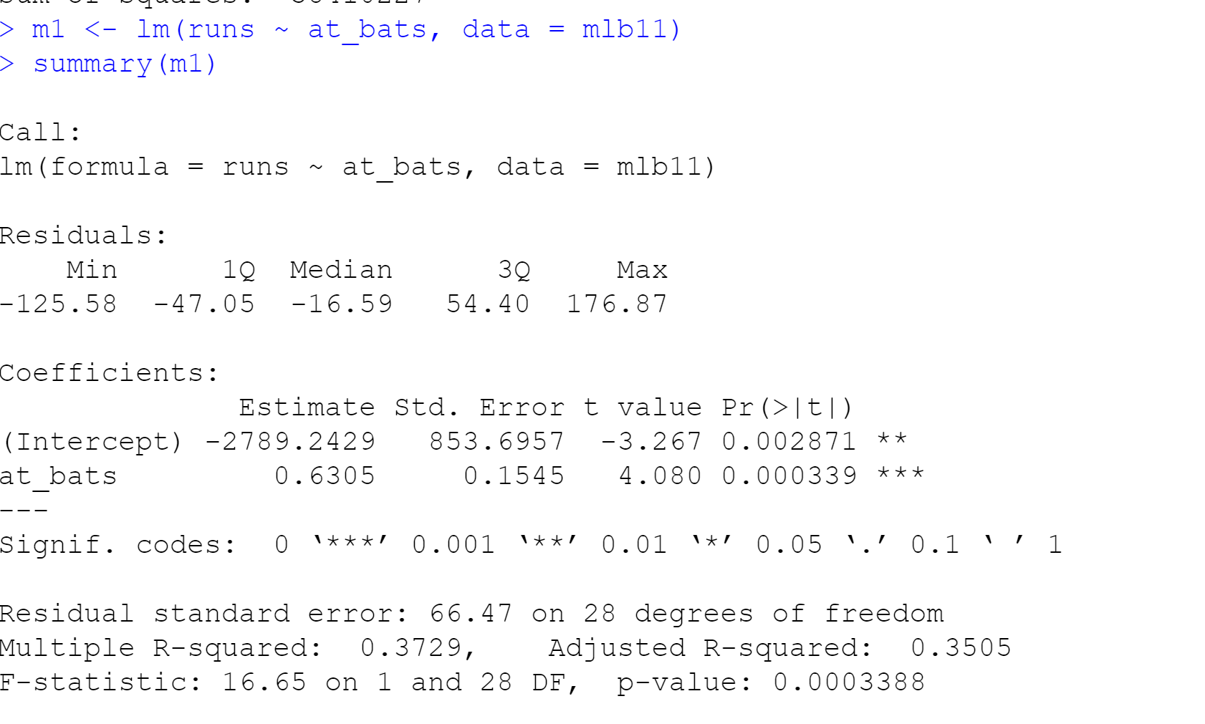
We found function: runs = -2789.2429 + 0.6305 * at_bats
A team with 5579 at_bats will make 728.3166 runs based on this function.
The residuals: e = y_{i} - y

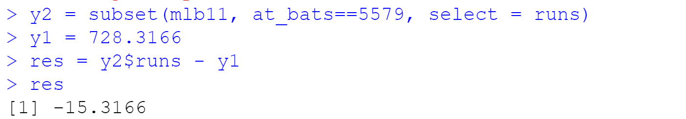
Therefore, this is an overestimate.

Exercise 6: Is there any apparent pattern in the residuals plot? What does this indicate about the linearity of the relationship between runs and at-bats? (Include plot.)

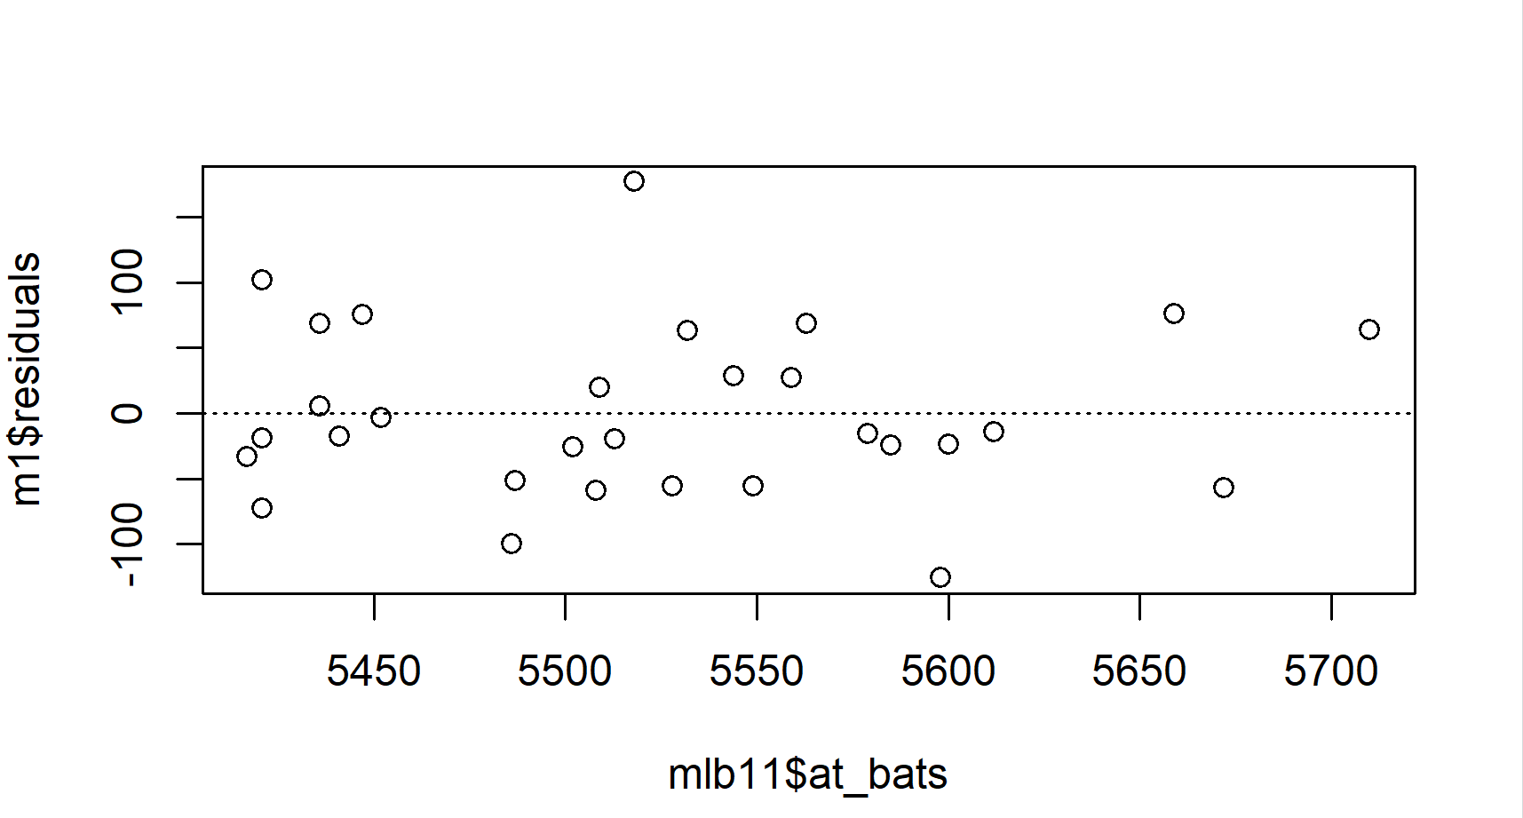
It is a nearly normal residual. We can verify this by the histogram.
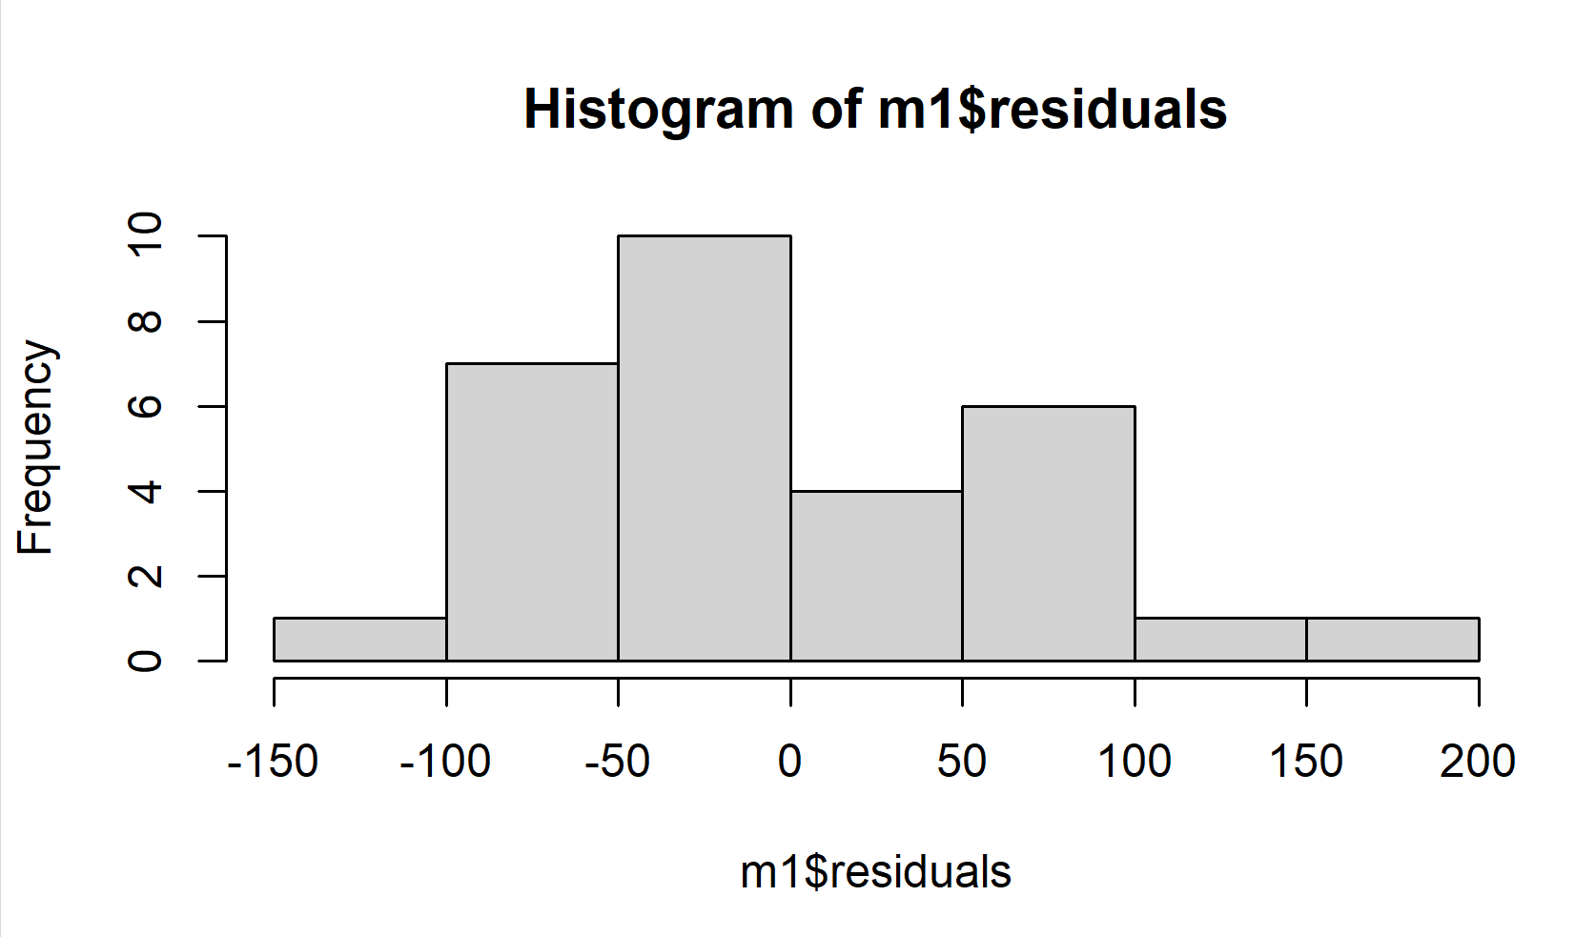
or a normal probability plot of the residuals.
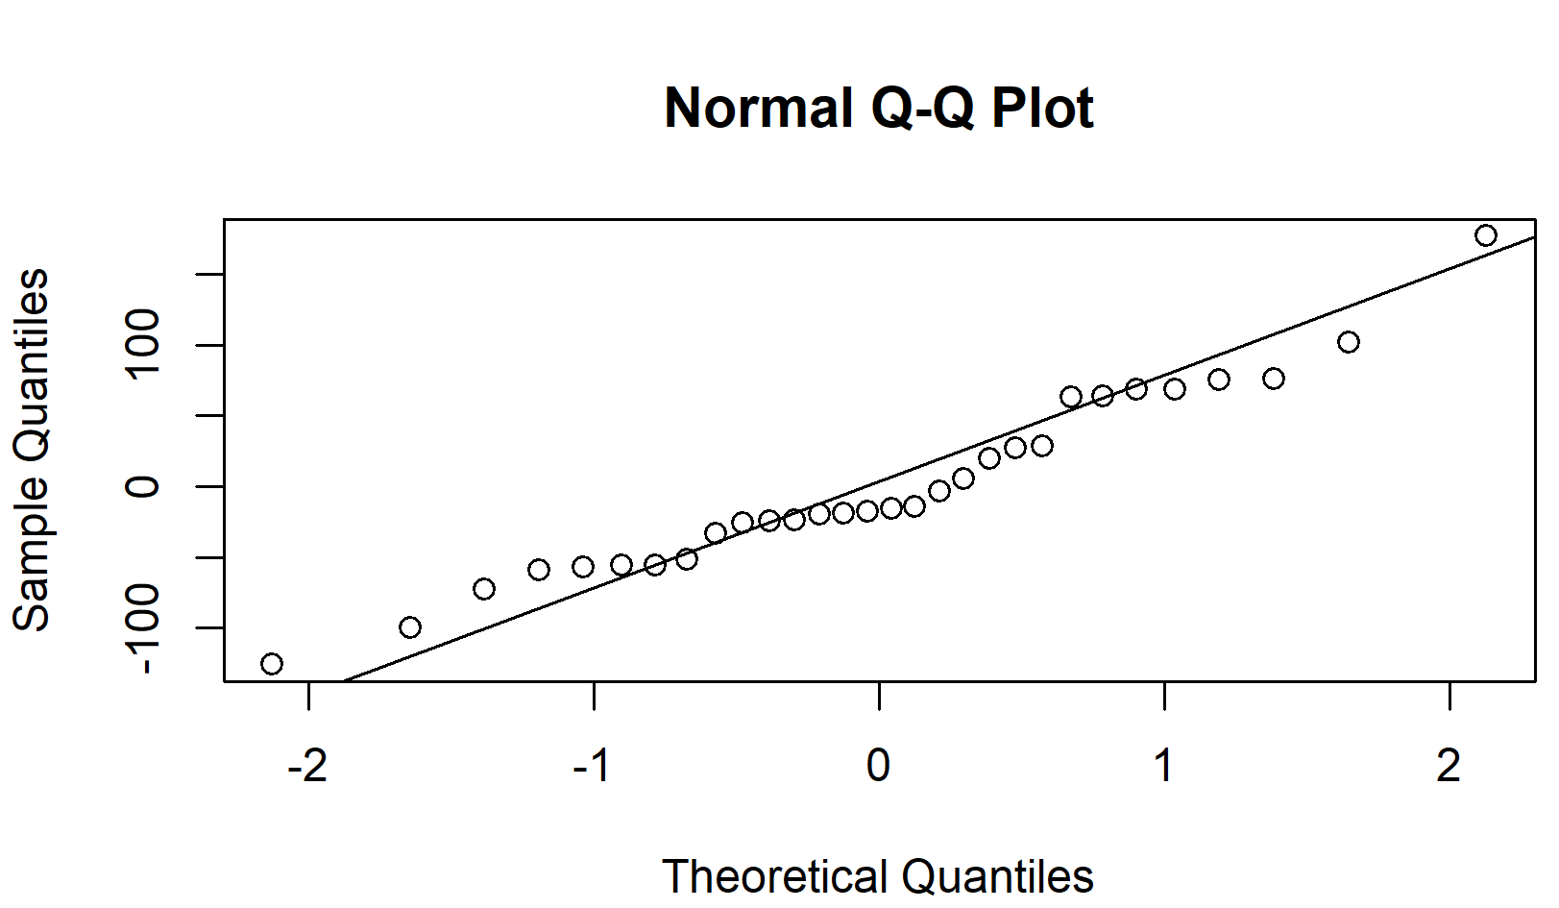
Therefore, the relationship between runs and at-bats is linear.

Exercise 7: Based on the histogram and the normal probability plot, does the nearly normal residuals condition appear to be met? (Include plots.)

There’s not a significant variance in the QQ plot. The histogram is pretty right-skewed, but not a lot. Hence, we can say that the nearly normal residuals condition appear to be met.

Exercise 8: Based on the plot in (6), does the constant variability condition appear to be met? Explain your answer.

The plot in (6) doesn’t show any significant variance so the constant variability condition appears to be met.

On Your Own:

1) Choose another traditional variable from mlb11 that you think might be a good predictor of runs. Produce a scatterplot of the two variables and fit a linear model. At a glance, does there seem to be a linear relationship? (Include plot.)

Another variable from mlb11 that might be a good predictor for runs is hits.
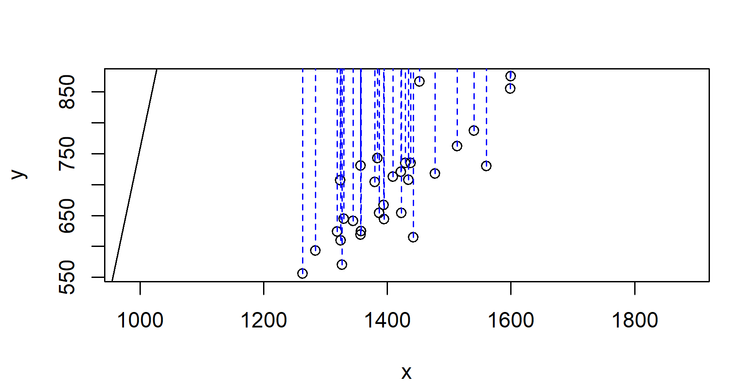

The relationship is linear. There seems to be a positive trend.
The correlation coefficient is: 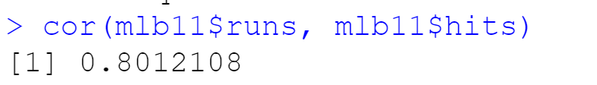
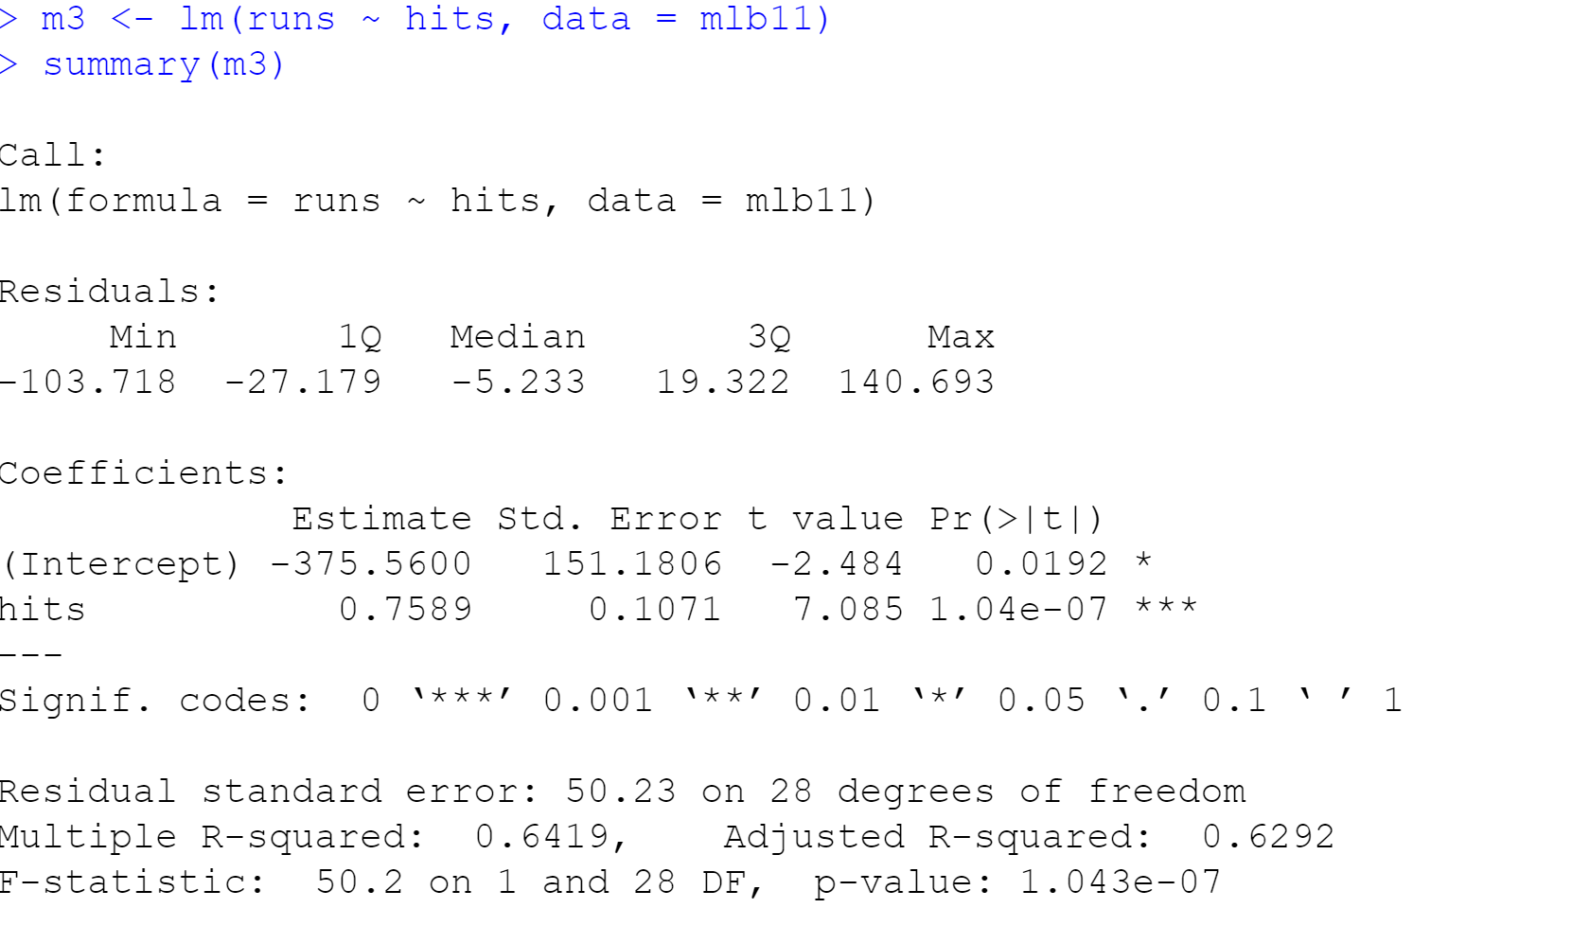
From the information above, we found the function: runs = -375.5600 + 0.7589 * hits

2) How does this relationship compare to the relationship between runs and at_bats? Use the $r^{2}$ values from the two model summaries to compare. Does your variable seem to predict runs better than at_bats? How can you tell?
R squared of the relationship between runs and at_bats is 0.3505.
R squared of the relationship between runs and hits is 0.6292.
The hits is a better predictor for runs since it has higher R squared value.

3) Now that you can summarize the linear relationship between two variables, investigate the relationships between runs and each of the other five traditional variables (we did at_bats and homeruns
already, now use hits, bat_avg, strikeouts, stolen_bases, and wins). Which variable best predicts runs? Support your conclusion using the graphical and numerical methods we’ve discussed (for the sake of conciseness, only include output for the best variable, not all five). (Include plot of the best one.)
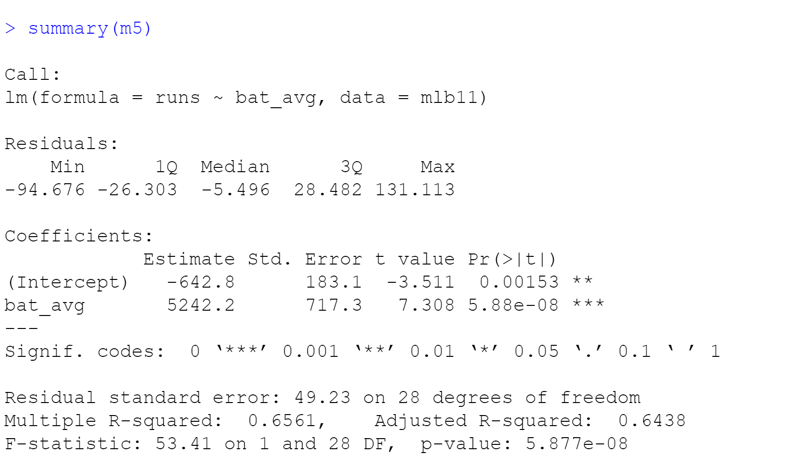
Batting average has the highest R squared value of all 5. So it is the best predictor for runs.

4) Now examine the three newer variables: new_onbase, new_slug, and new_obs. These are the statistics used by the author of Moneyball to predict a team’s success. In general, are they more or less effective at predicting runs that the old variables? Explain using appropriate graphical and numerical evidence. Of all ten variables we’ve analyzed, which seems to be the best predictor of runs? Using the limited (or not so limited) information you know about these baseball statistics, does your result make sense? (Include plots.)
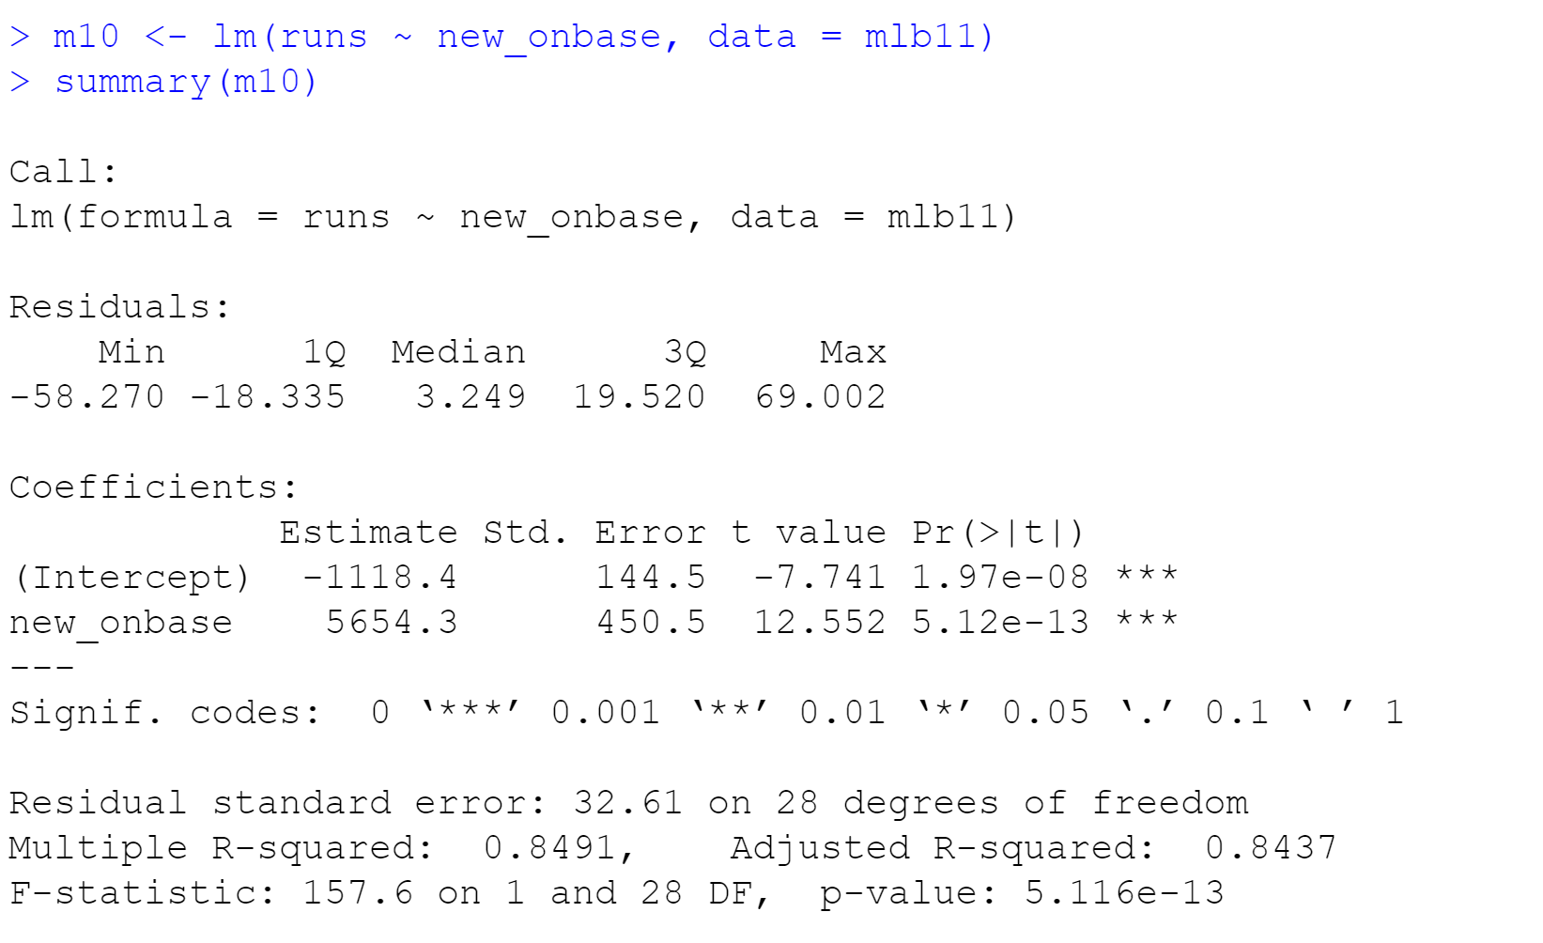
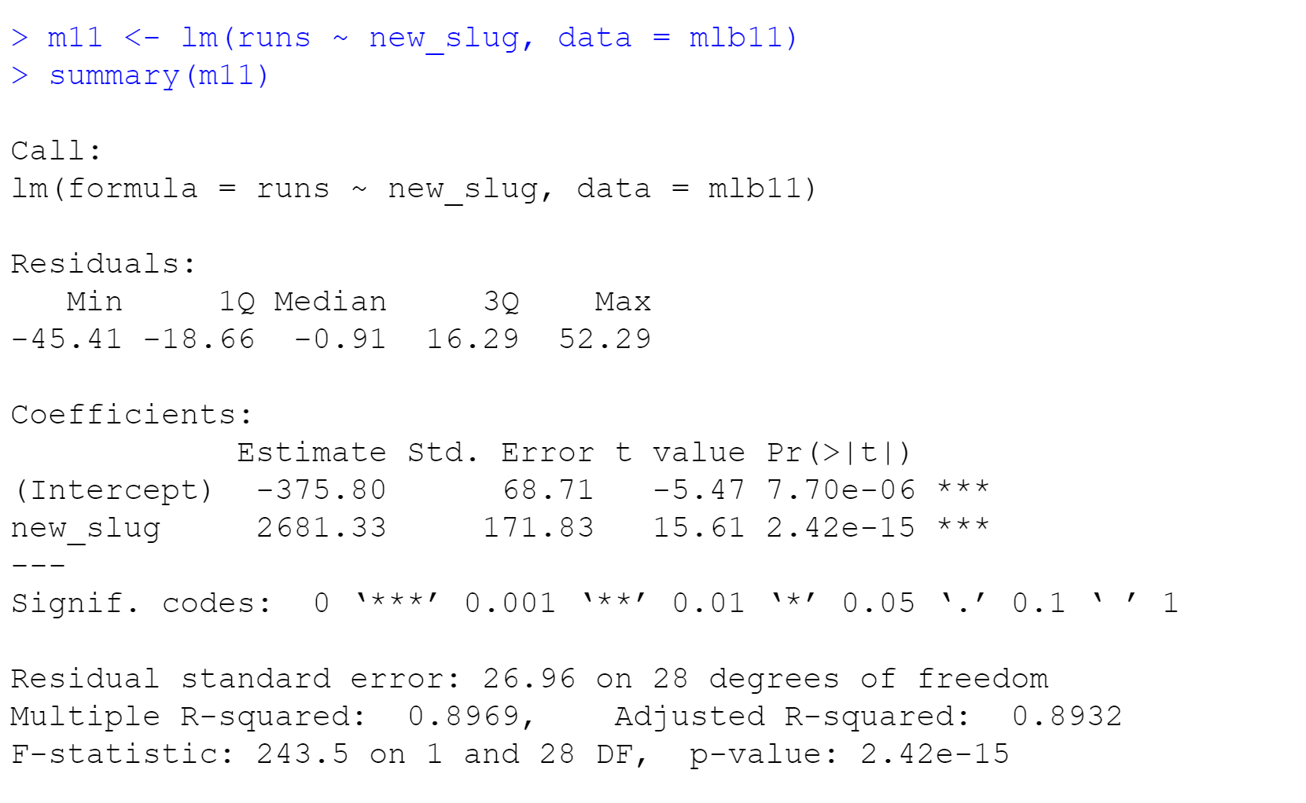
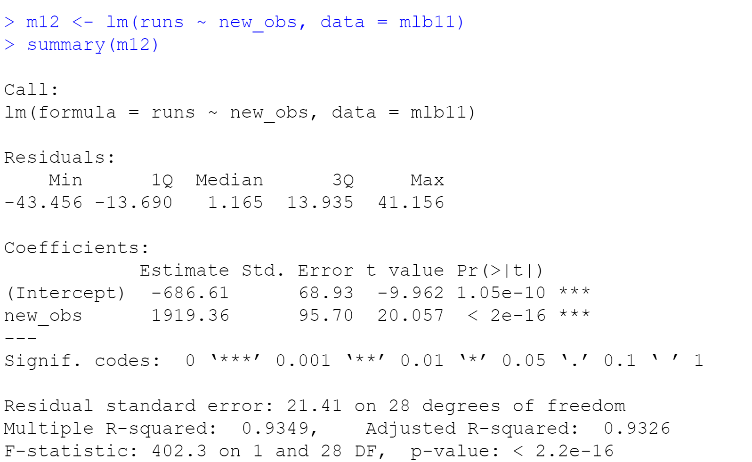
The R squared value of the relationship between runs and new_obs is 0.9326, which is the highest of all three new variables. This value is higher than the R squared value of the relationship between runs and batting average. So new_obs is the best predictor for runs.
Other than that, the R squared values of the three new variables are all higher than that of the old ones, so the new variables are better predictors for runs.

5) Report the model diagnostics ($r$ and $r^{2}$) for the regression model with the variable you decided was the best predictor for runs. Interpret them in context.
The best predictors for runs were decided to be new_obs and batting average.
Histogram (new_obs):
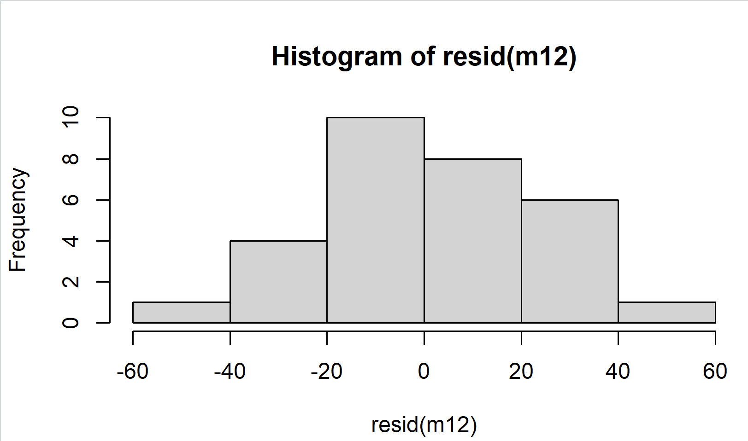
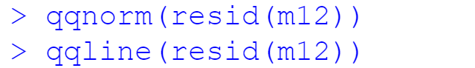
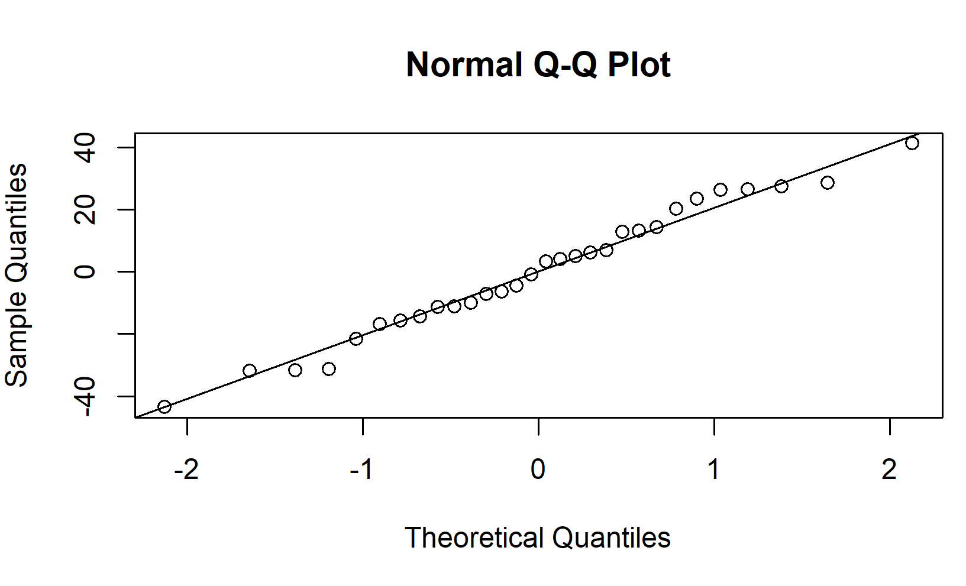

Histogram (batting average):
